[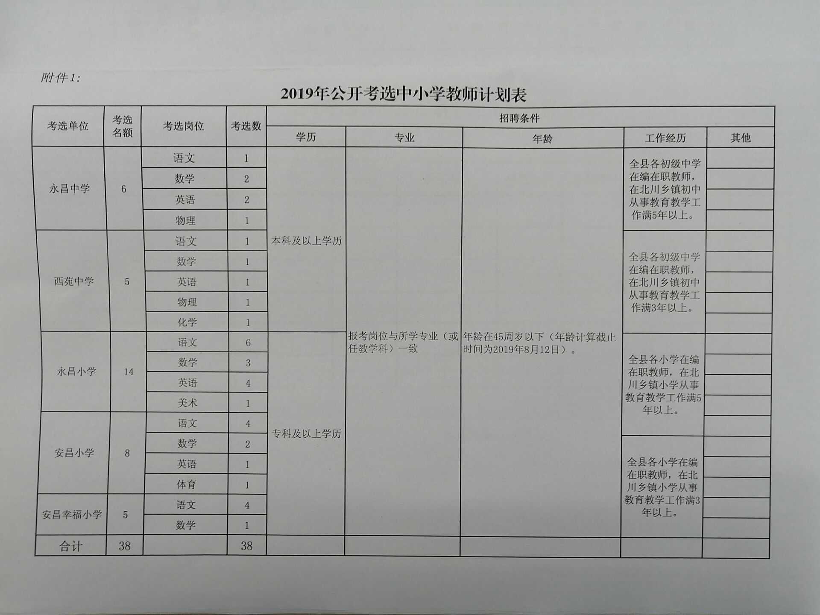](http://login.www.beichuan.gov.cn:80/_img/2019/08/07/20190807151135264.jpg)